ANTIQUE MOTORING CLUB OF MONMOUTH COUNTY
ENDLESS SUMMER CAR SHOW
co-sponsored by
CLEAN WATER CLAM COMPANY OF SEA BRIGHT
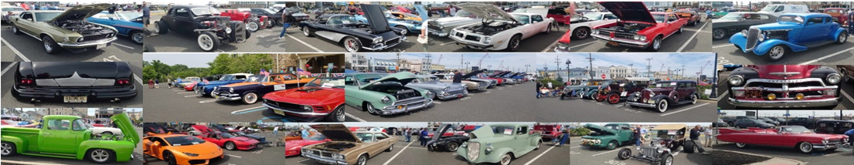
SATURDAY, SEPTEMBER 21, 2024 | 10AM to 2PM
Borough Hall, 1099 Ocean Avenue, Sea Bright
Rain Date: Saturday, September 28th
Food Trophies Fun
LIVE MUSIC BY “JUST KILLIN’ TIME”
$20 ADMISSION DAY OF SHOW
NO PRE-REGISTRATION

DASH PLAQUES AVAILABLE FOR FIRST 200 REGISTRANTS

For questions or more info: 732-982-RIDE (7433) / events@amcomc.org

no burnouts, loud music or alcohol permitted

