MIRA VIE at TINTON FALLS
proudly presents
CARS & COFFEE
with classic cars provided by the
ANTIQUE MOTORING CLUB OF MONMOUTH COUNTY

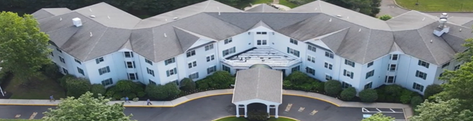

SATURDAY, MAY 11, 2024
9:00 AM – 12:00 NOON
1 HARTFORD DRIVE, TINTON FALLS

A DISPLAY OF CLASSIC CARS FOR THE RESIDENTS’ ENJOYMENT
PLEASE CONTACT DAN LADEN @ 732-615-8587 TO BRING YOUR CLASSIC CAR
REFRESHMENTS & RESTROOMS ON SITE

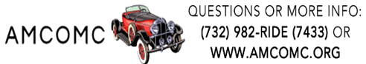

Club members are invited to participate by Mira Vie at Tinton Falls. The “Attendee” assumes all responsibility for all related risks, dangers, and hazards, and agrees that AMCOMC is not responsible for any injury, damage, or cost caused by or to “Attendee” with respect to any person or property. All property losses, including damage to private property, vehicles, and/or personal injuries are the sole responsibility of “Attendee”. Submissions of claims for insurance reimbursement must be submitted by “Attendee” under their own personal or vehicular policy(ies). Any vehicle utilized is required to be insured and registered.

